Recycling Your Pastel Pieces –Gary Binder
What can you do with bits and pieces of pastels? Recycle them to new sticks is one option. Pastel sticks are basically pigment and clay with a binder making the recycling possible with water or other solvents. Here are some steps if you want to try this:
First begin collecting until you have enough bits to make a few sticks. Finding a few sticks to add to the mix with more clay to pigment ratio will help make your recycled sticks more durable. I use old medicine containers as a judge of one stick per container. Try to save them in both color families and warm and cool colors. Otherwise an assortment will likely result in some form of grey.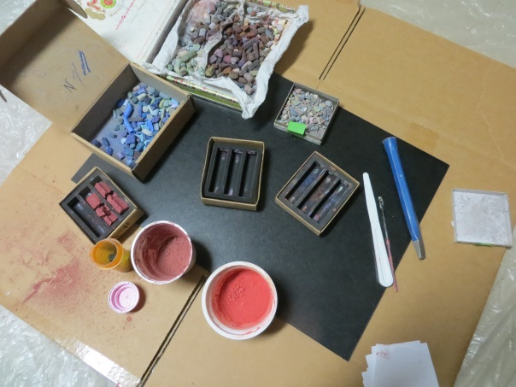 You’ll also need a mold of some sort. I find the foam inserts from original pastel sets work fine. If you don’t have any, go to your local art store and ask for a few. For this example, I’m using the harder foam in a large size. I find the closed cell foam works best (vs. more porous types). When you have the bits and molds ready, get the rest of the items you’ll need to grind and mix the pastel bits into dust size and ultimately to a paste consistency. Planning your cleanup is important. I use disposable plastic or newspaper to spread out on, and have plenty of molds and yogurt cups available that can be thrown away. This is a process that creates hazardous dust so it is best to do outdoors and wear a mask if you want the ultimate protection for your health.
Begin to select bits and put them in yogurt cups for grinding. I find that doing all the grinding serially cup to cup minimizes time with dust. As you finish grinding one cup, place a cover on it and go to the next until all are done.
Here are a few examples of ground bits.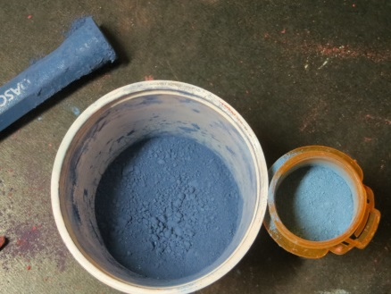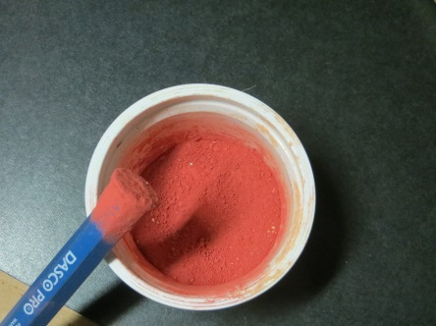
Note that I use a steel cold chisel end as my grinding tool, but you can pick anything that works. Also I like to use yogurt cups since they seem to be the right size for a few sticks worth of dust.
Decide what colors you want to mix, and whether you want a solid color or solid with specs of other colors. The mixing stage will be slightly different for either. As you grind the bits you can add pieces of various colors/temperatures to get to a desired end result. Note also in the following picture that nuggets of bits are surfacing as you grind. You can pulverize these or save a few to use as color flecks.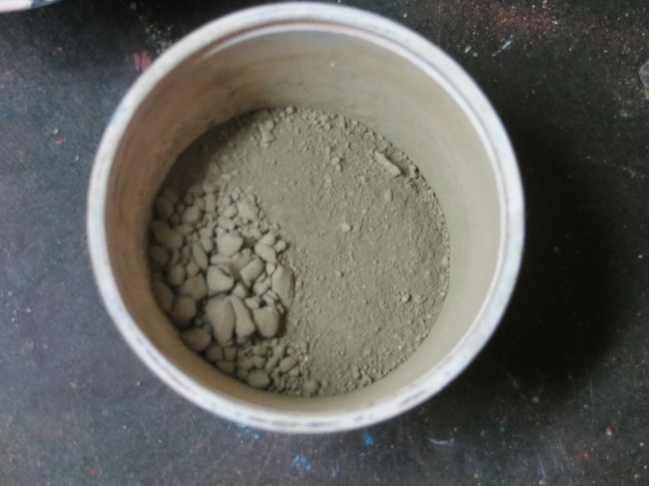
Nuggets: Save these if you want to use them as flecks later or continue to grind into dust
For the next step, begin to mix in water sparingly until you have a thick paste. If you want to make a solid color, proceed to scooping the paste into a mold. Making a flecked stick requires the addition of nuggets of color at this point. Try adding warm bits to a cool stick or vice versa. Add a complement if you wish, but be careful not to over mix otherwise the stick will grey or loose the intended color you desire.
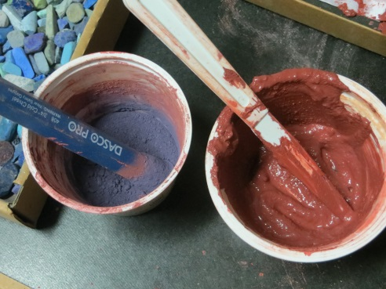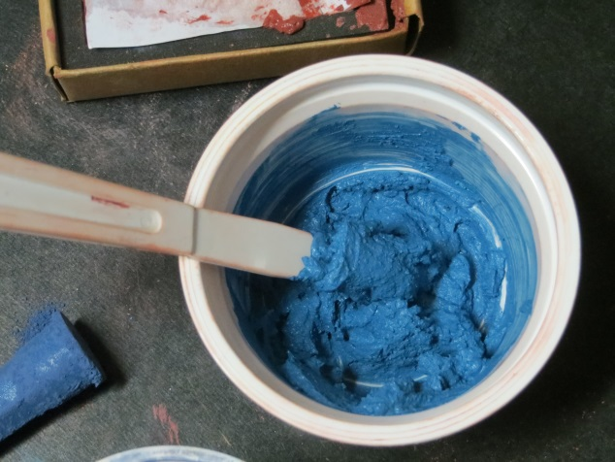
Next scoop the paste into a mold. I’ve tried different ways to do this. One is using a paper wrapper, and one without. Either seems to work, but the most success has resulted from firmly pressing the paste into the mold to let excess water and air rise to the surface.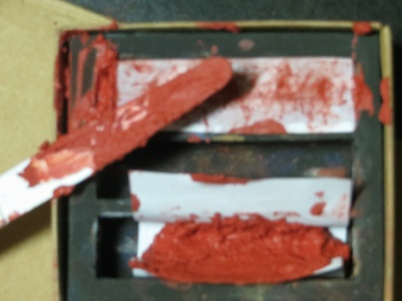 Fill all your molds and set aside for at least 24 hours. Saving this for warmer months in Arizona speeds the process. After a day, carefully remove the still wet sticks and separate on a flat surface. Any stick that is not molded well or crumbles simply put in a container for next time. Leave the successful ones on the flat surface for at least a week. Here are some of my latest results. The sticks with a good consistency are ones where more pressure was used in the molding stage. Since these are about twice the size of a “Ludwig” I typically cut them in half (A chunk for the studio and one for plein air).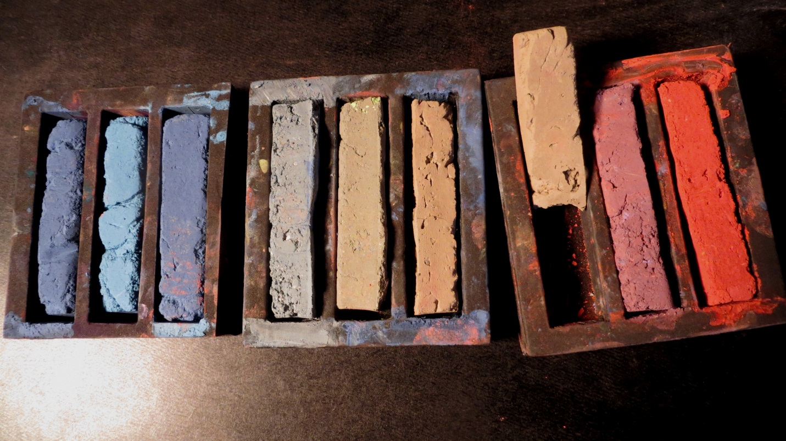
When I made these I wanted to create some landscape colors typical of Sedona area surroundings. The neutrals in the center also have some color flecks of warmer color nuggets for a fun way to establish a desert ground plane.
While this is a bit messy, it’s also fun when you get good results. This is about half of what I made in an hour and a half. Assuming $3-5 per stick for higher end pastels, my set made this day (10 sticks) is about $40 retail value.
Maybe I’d be better off simply buying the sticks and using the time to paint instead, but I like to know how things are made, so have tried this a few times now. My first trial took about twice the time with mediocre results, so be patient. When you think of the varieties and quantities that pastel manufacturers generate, this may give you a better appreciation of the effort and cost of producing a high quality stick.

